# Random Forest in Sleep Stage Prediction Model

## Architecture

The initial random forest used was a default random forest offered by scikit-learn.ensemble package of python. The default parameters for the random forest are as follows :-

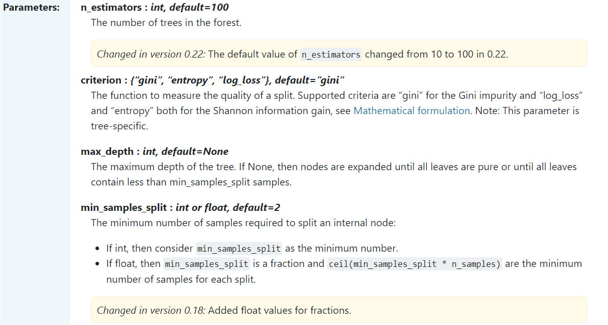

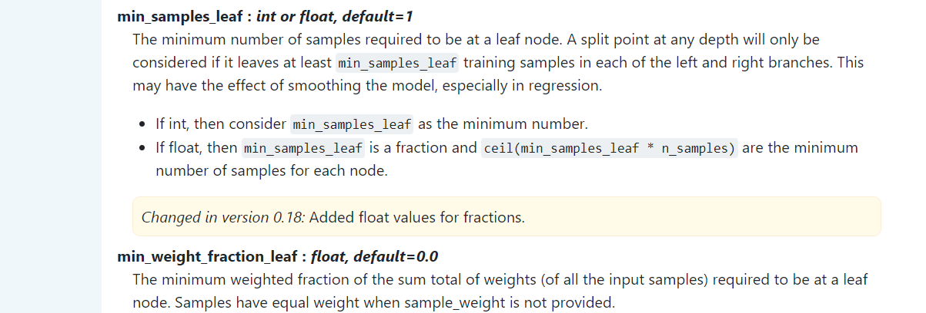

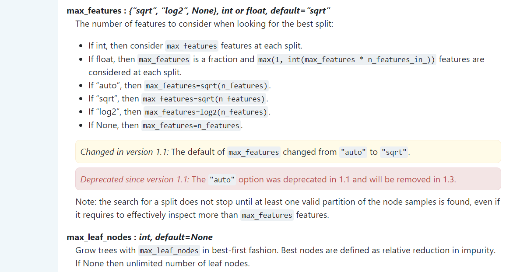

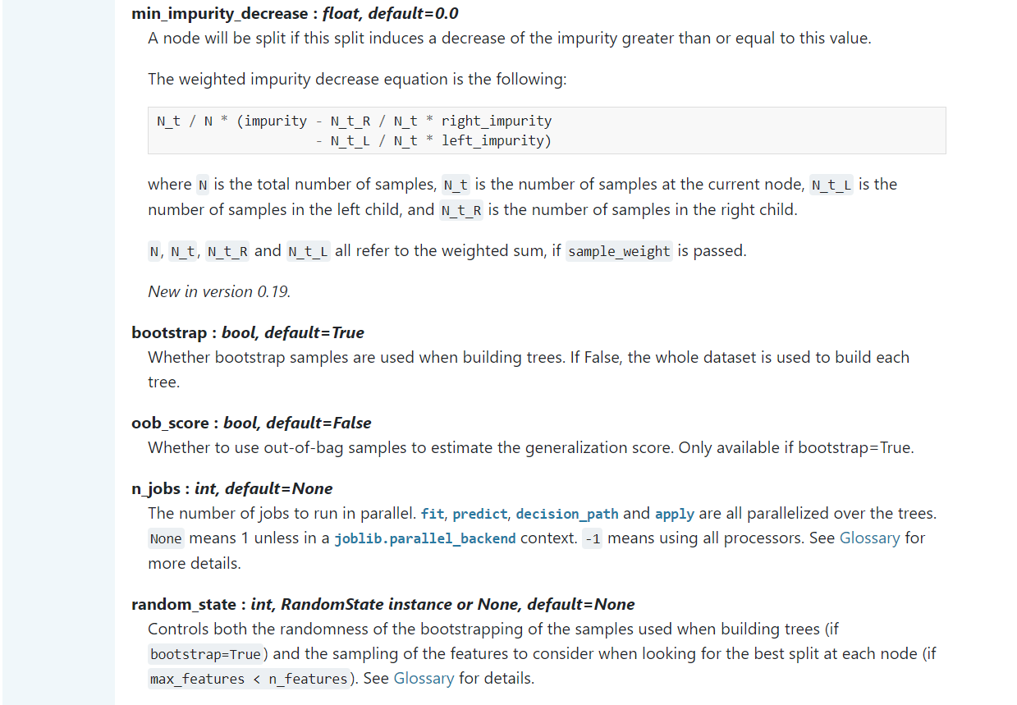

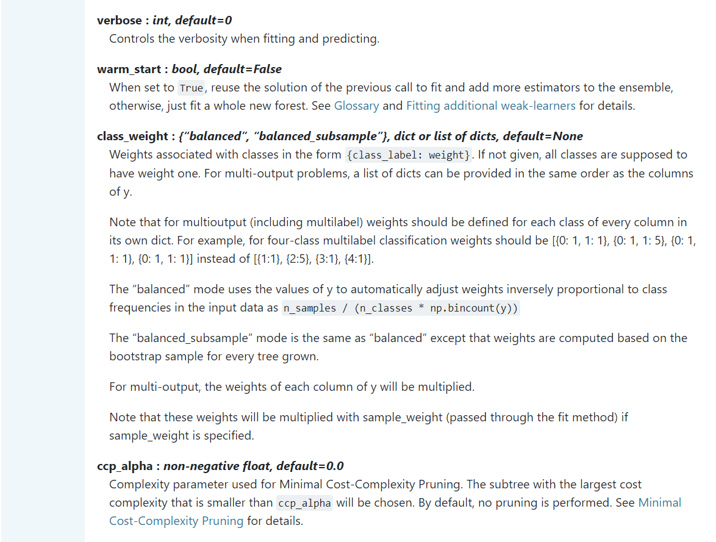

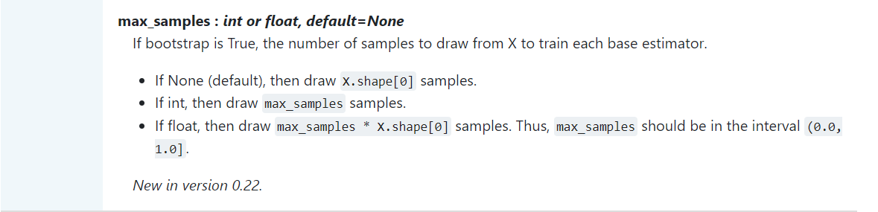

The parameters that we have used are :-



Keeping other parameters as default.

The {n_estimators=10} limits the number of decision trees to 10. This optimizes the size and performance of the random forest. The {criterion=”entropy”} sets the criteria for splitting in each decision tree as weighted entropy. The {max_depth=14} sets the maximum depth of each decision tree as 14, thus preventing any decision tree from underfitting or overfitting.

## Classification Report

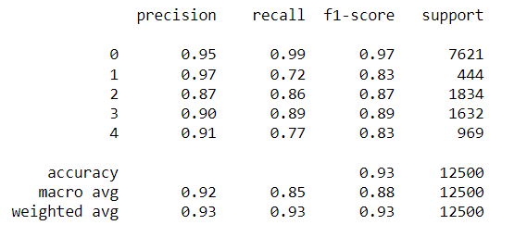

## Github Repository

<https://github.com/Jibitesh-Chakraborty2811/Sleep-Stage-Random-Forest-Classifier>